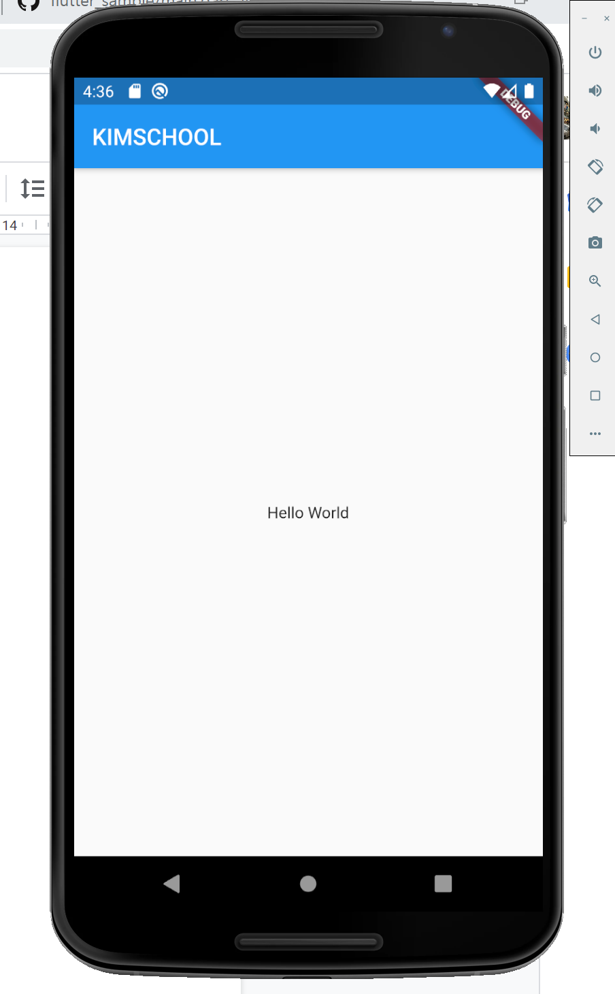

import 'package:flutter/material.dart';

void main() => runApp(MyApp());

class MyApp extends StatelessWidget {

// This widget is the root of your application.

@override

Widget build(BuildContext context) {

return MaterialApp(

home: Scaffold(

appBar: AppBar(

title: Text("KIMSCHOOL"), // 타이틀 Text

),

body: Container(

child: Center(

child: Text("Hello World"), // 본문 Content

),

)

),

);

}

}